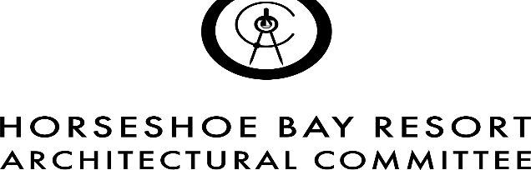

ARCHITECTURAL CONTROL COMMITTEE (ACC)

**Standard Architectural Policy (SAP)**

**General Standards for Paint Colors:**

**Per the Horseshoe Bay Architectural Standards section 3.1.2.4(b), paint colors are required to have a specific Light Reflective Value (LRV):**

**• Light or bright colors having an LRV value greater than 44 are not acceptable.**

**• White paints may not have an LRV over 85.**

**• Exterior wall colors may not have an LRV over 50, unless being painted white.**

**• Trim and accent colors shall have an LRV value equal to or less than 55.**

**Rather submitting an application for repainting an existing home, or for new construction, you must include the paint’s LRV along with your color samples.**

**Your paint supplier will be able to assist with determining the LRV of your choice of colors.**

**Be advised, requests for project approval may require other, existing non-compliant issues to be addressed including but not limited to:**

* Adress yard lights
* Mechanical and Utility Equipment Screens and Trash Enclosures
* Landscapes not installed or maintained to minimum standards.
* Removal of non-approved exterior elements added without ACC and/or City approval.